Feature Extraction from Text

Definition
# Source: AI Source: Provided by: [Data Path: Persons Table -> ID Column: 1, Name_En Column: Motasem Essam] -> From: [ChatGPT] on [12/10/2025]
Feature Extraction from Text is a text transformation technique that converts raw text into structured, measurable features that can be used in data analysis, machine learning, or NLP models. These features capture useful information from the text beyond just word counts.

Key Idea
# Source: AI Source: Provided by: [Data Path: Persons Table -> ID Column: 1, Name_En Column: Motasem Essam] -> From: [ChatGPT] on [12/10/2025]
Instead of using the raw text directly, we extract meaningful properties such as word frequency, length, presence of keywords, or sentiment indicators. These features help algorithms detect patterns and relationships in textual data.

Common Text Features
# Source: AI Source: Provided by: [Data Path: Persons Table -> ID Column: 1, Name_En Column: Motasem Essam] -> From: [ChatGPT] on [12/10/2025]
- Word Count / Token Count
  - Measures the total number of words or tokens in a document.
  - Example: "I love this product" → Word count = 4
- Character Count
  - Total number of characters in the text.
  - Example: "I love this product" → Character count = 19
- Average Word Length
  - Sum of word lengths divided by number of words.
  - Example: "I love this product" → Average word length = 19 / 4 ≈ 4.75
- Presence of Keywords / Specific Words
  - Binary or frequency indicators for important words.
  - Example: "good" in review → 1 if present, 0 if absent
- Sentiment Features
  - Indicates positive, negative, or neutral sentiment based on text.
  - Example: "I hate this" → Sentiment = Negative
- TF-IDF or Word Embedding Features
  - Captures importance or semantic meaning of words in the context of the dataset.
- Punctuation or Special Character Counts
  - Counts exclamation marks, question marks, hashtags, etc.
  - Example: "Amazing!!!" → Exclamation count = 3

Example
# Source: AI Source: Provided by: [Data Path: Persons Table -> ID Column: 1, Name_En Column: Motasem Essam] -> From: [ChatGPT] on [12/10/2025]
Original dataset:
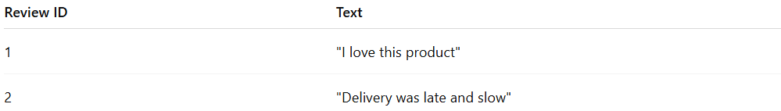
Review ID | Text
1 | "I love this product"
2 | "Delivery was late and slow"
Feature extraction:
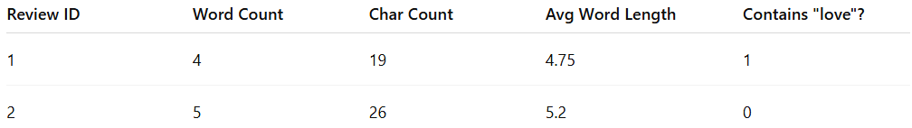
Review ID | Word Count | Char Count | Avg Word Length | Contains "love"?
1 | 4 | 19 | 4.75 | 1
2 | 5 | 26 | 5.2 | 0

Advantages
# Source: AI Source: Provided by: [Data Path: Persons Table -> ID Column: 1, Name_En Column: Motasem Essam] -> From: [ChatGPT] on [12/10/2025]
- Converts text into structured numeric features
- Highlights important patterns in the text
- Can improve model performance for classification, regression, or clustering

Disadvantages
# Source: AI Source: Provided by: [Data Path: Persons Table -> ID Column: 1, Name_En Column: Motasem Essam] -> From: [ChatGPT] on [12/10/2025]
- Feature selection requires domain knowledge
- Can create high-dimensional data if too many features are extracted
- May miss contextual meaning if only simple features are used

